Same as objects in javascript

It is a collection of key : value pair

**Making dictionary**

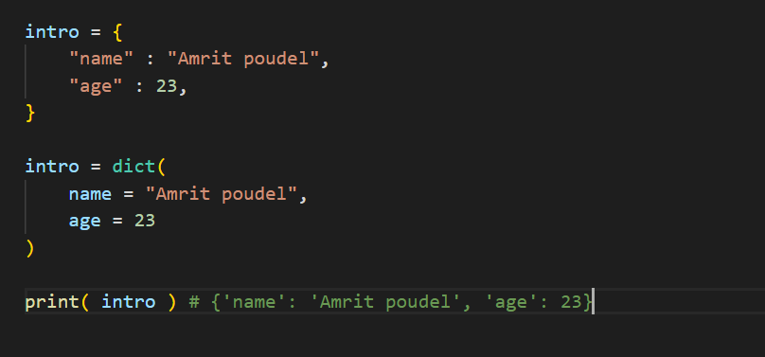

**These methods**

**.items( )**

Get key values

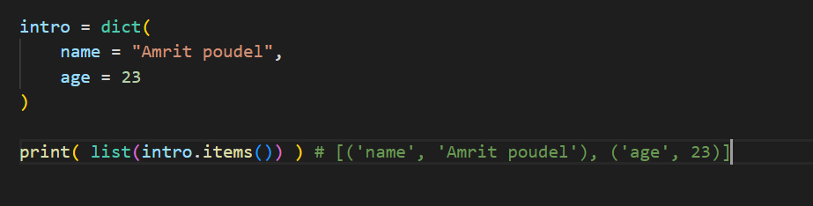

**.keys( )**

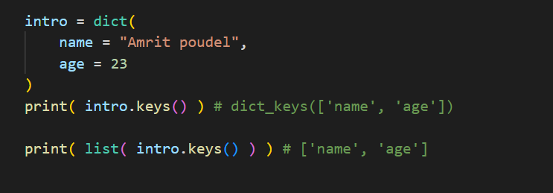

Gets the list of keys of dictionary

**.values( )**

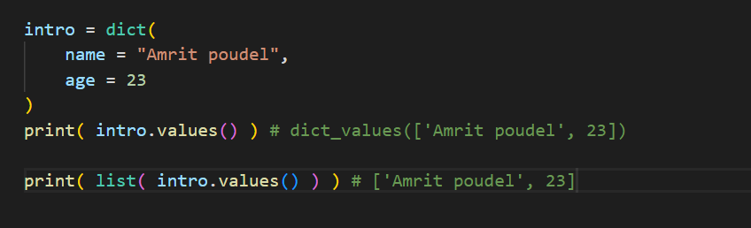

Gets the list of values of dictionary

**Add item / change item**

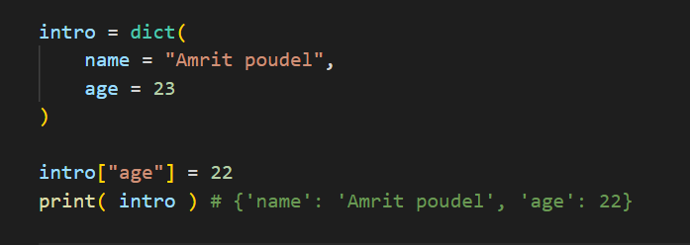

Changing item

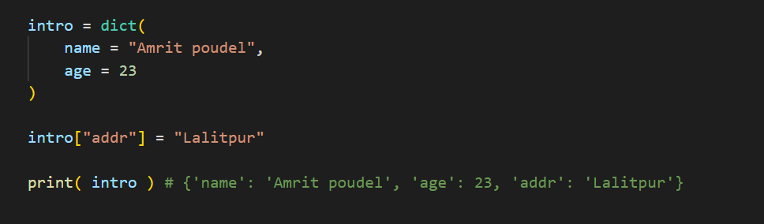

Adding item

.update ( ) method

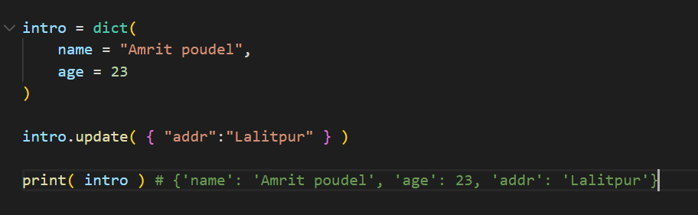

**Removing items**

popItem ( )

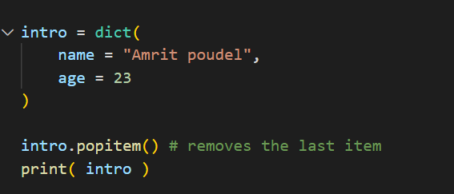

del keyword to remove an item

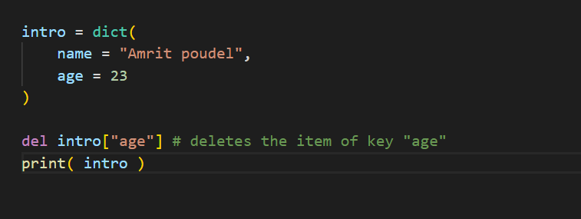

del keyword also deletes the whole dictionary

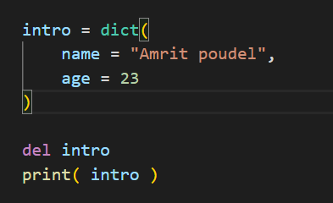

**.clear ( )**

Empties the dictionary

Clears the dictionary

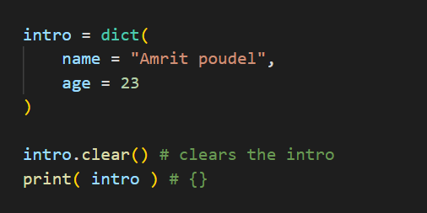

Copying the dictionary

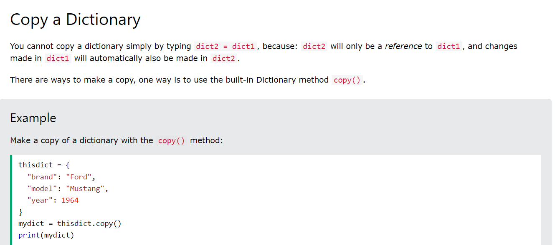

Since directly assigning will cause both variables pointing to the same dictionary so we use the .copy ( ) method